FOR IMMEDIATE RELEASE
February 21, 2023

POLYMORF and Studio Biarritz U.S. TOUR confirmed with Texas premiere of SYMBIOSIS.
In partnership with PAM CUT // Center for an Untold Tomorrow and IDFA DocLab
Award winning multi-sensory XR Experience SYMBIOSIS
selected at SXSW in the XR program
March 11, 2023 – March 14, 2023

The U.S. tour of Dutch interdisciplinary artist collective POLYMORF is confirmed with a Texas premiere at SXSW. From March 11-14, the multi-sensory VR installation SYMBIOSIS will be presented as part of the SXSW XR Experience Spotlight section.
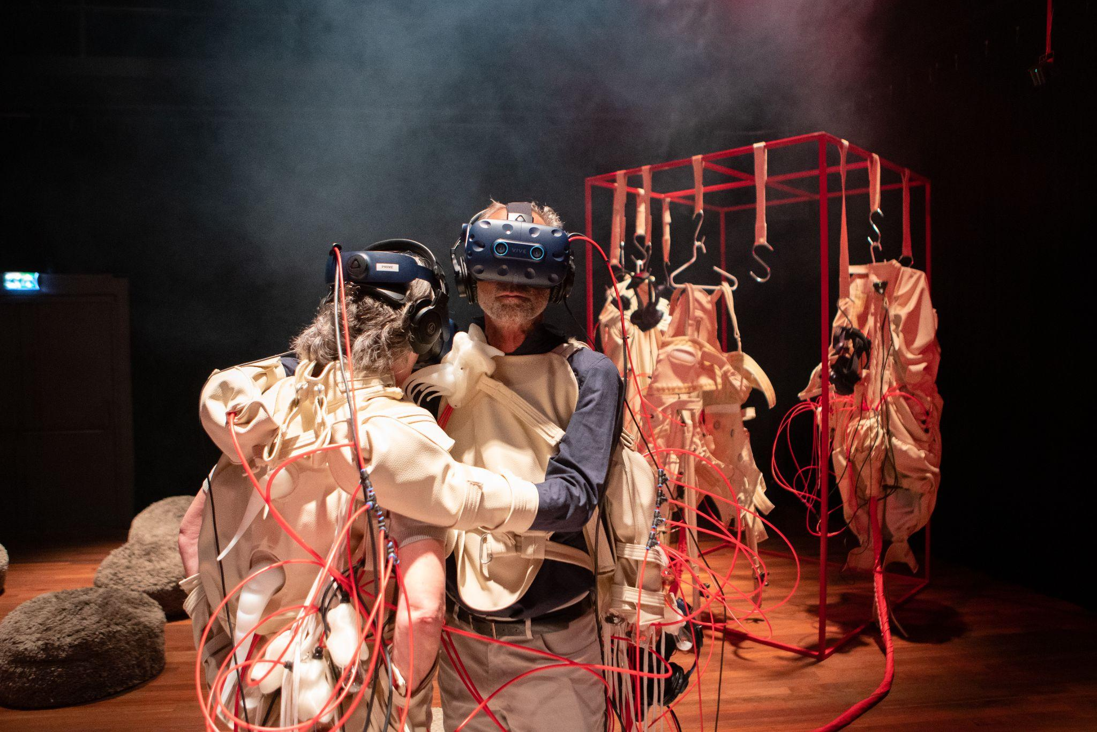

SYMBIOSIS had its world premiere at IDFA DocLab in Amsterdam and its U.S. premiere at PAM CUT // Center for an Untold Tomorrow in Portland, Oregon. The participatory XR work sold out for three consecutive months at the Portland Art Museum's cutting-edge media arts space. Following both sold out runs, SYMBIOSIS now invites the SXSW audience to explore its speculative world, 200 years into the future, where a rich biosphere of mixed symbiotic life-forms has taken over the earth's ecosystem. In a virtual world, with augmented scent, soft robotics and food snacks, the participant becomes a symbiont: a human-animal, and human-machine hybrid.

About the Experience
SYMBIOSIS is one of the first multi-sensory XR (extended reality) storytelling experiences, an award-winning performative, multi-user installation that takes the art of immersive storytelling to a whole new level. Through individualized haptic suits and soft robotics, as well as taste and smell-based story elements, the human body will be experientially redesigned to merge with technology and nature itself. Brought together in one VR experience for six participants, you explore a world changed beyond recognition which you can taste, hear, see and feel.
The latest from Dutch experience design collective Polymorf by directors Marcel van Brakel and Mark Meeuwenoord, in co-production with Studio Biarritz, brings you a vision of a future after climate change has changed the world beyond recognition. This post-human biotope is rich and teeming with new artificial or enhanced biochemical life: new genetically altered life forms, (chemical) robots, hybrid technologies, and/or autonomous intelligent systems. They are all sharing resources, habitats, bodies and information in an inclusive way. There is no competition, only symbiosis. There are different character experiences that describe a specific symbiotic human-animal or human-technologic relationship. The performative allows each participant to embody one of these symbiotic life forms, using all five senses to transform into entirely new beings and envision a post-human world.
SXSW facts & program
- location | SYMBIOSIS will take place at the Congressional Ballroom at the Fairmont. Booth | 210, Duration: 45min | Maximum participants: 6
- interviews & partnerships | Director Marcel van Brakel, producer Corine Meijers and Marieke Nooren (sales and distribution) will be available for interviews from 11 till 14th of March (details at the bottom)
- panel | Marcel van Brakel will join the panel The Art of Sensory XR hosted by IDFA DocLab and Polymorf at SXSW | 14th of March at the Fairmont 4-5pm > more info here
- partners | the SYMBIOSIS SXSW showcase is supported by the Dutch Culture USA program of the Consulate General of the Kingdom of the Netherlands in New York, Creative Industries Fund NL, Film Fund NL, See NL, Popkraft, PAM CUT//Center for an Untold Tomorrow, and IDFA DocLab.
- additional information on www.symbiosis.show or check the bottom for press of this press release for contact details

Award winning XR
The world premiere of SYMBIOSIS was at IDFA DocLab in 2021 in Amsterdam, where it was presented in collaboration with Eye Filmmuseum, and won the IDFA DocLab Creative Technology award in the Immersive Non-Fiction competition. The jury wrote: “the creators take us to all corners of their world, asking us to explore the role of all your senses in a story. This combination of design, engineering, audiovisuality, and multi-sensoriality surely plays an integral role in the future of immersive experience.” Since then the artwork has toured through the Netherlands, showing at prestigious events and selling out immediately at the national Eye Filmmuseum, Holland Festival and the Netherlands Film Festival. Last fall, Polymorf crossed the ocean and has been embraced by the visionary PAM CUT // Center for an Untold Tomorrow to host SYMBIOSIS for a generous three-month run, since November 12 last year. The show is highly successful, leading to an extension until February 26th, this year.
“Polymorf’s experiential and immersive works—and their clever use of scent especially—have blown my mind for years,” said PAM CUT Director Amy Dotson. “SYMBIOSIS is the kind of transformational interactive storytelling that really reflects who we are at PAM CUT and what we want to do with artists and partners. We are so thrilled that Polymorf trusted us with the U.S. premiere, which our community absolutely loved. We can’t wait for more audiences to snuggle up in their haptic suits, strap on their VR glasses and travel into this brave new world of storytelling.”
Selected press from the winter 2022
“Bodysuits, custom scents and snacks: SYMBIOSIS at Portland’s PAM CUT challenges our view of reality.” — OPB's Oregon Art Beat (short film and creator interview)
"Inspired by ecofeminist scholar Donna Haraway’s Staying with the Trouble, SYMBIOSIS is quite possibly the most immersive—and coolest—art experience to hit Portland in a long time."
— Portland Mercury/EverOut
"Portland Art Museum’s new VR experience, SYMBIOSIS, will have you donning a robotic suit faster than you can say 'ecofeminist Chthulucene.'” — Oregon ArtsWatch
“It might have been the oxytocin being pumped in through the scent tubes, but there seemed to be a real sense of camaraderie between us. This despite the fact that most of us (save the multibody creature) went through the experience alone.” — The Oregonian
SYMBIOSIS is inspired by Donna Haraway's book Staying with the Trouble, in particular its chapter “The Camille Stories: Children of Compost” in which the noted ecofeminist scholar imagines a post-humanist future with humans and monarch butterflies ‘symbiogenetically’ joined. An all female cast including the voice of award winning film editor Maya Daisy Hawke has given voice to the characters of SYMBIOSIS, which include storylines of a Colorado river toad, a slime mold, a flowering camellia, and anglerfish, among others. Every creature has a custom design with a smell scenario, designed by Polymorf, that is specifically made for each story experience, and Dutch fashion artist Maurice Spapens designed the costumes.
How it works
In SYMBIOSIS, the participant is both spectator and performer. By choosing one of the character stories, the participant selects a character and role in the overall story world. All participants play a different symbiotic role in each other's individual lives. Each experience comes with a uniquely designed soft robotic suit that manipulates your body, transforms your posture and sensory perception of the SYMBIOSIS world. VR sensors attached to your creature’s suit will reveal your post-human body, enabling you to play and move in the SYMBIOSIS world. The VR headsets are also equipped with olfactory fixtures emitting specially designed aromas that release in sync with each specific experience.
The individual experiences build towards a collective eating ritual—sharing virtual and real foods, and the virtual body as food. For this, a series of specially designed snacks infuse the virtual food with unexpected taste sensations. The vegetarian snacks will be designed by master chefs Ingrid van Eeghem and Jaap Krabbendam from Dutch restaurant Karpendonkse Hoeve. SXSW and POLYMORF staff will monitor and assist participants throughout the entire experience. Each session runs for roughly 45 minutes and up to six people can participate at a time.
THE TEAM
Polymorf
Dutch interdisciplinary experience design collective Polymorf designs by any media necessary to create speculative design and multi-sensory experiences using cutting-edge technologies. Their groundbreaking work engages audiences by creating fully embodied immersive experiences. This is reflected in their body of work, which consists of VR experiences, theatrical performances and installation pieces. SYMBIOSIS came forth from an ongoing exploration into the possibilities for scent and touch to create multi-sensory strategies for story and experience design, working closely with various industries and universities all over the world. By directly influencing the affective response, Polymorf incorporates visceral meaning in their designs to reflect on the now, the (post-)human condition, and the relationships between humans and technology.
Studio Biarritz
Studio Biarritz, founded by Corine Meijers in 2019, is now an established production house that specializes in audiovisual projects that cross borders. Studio Biarritz develops its own projects, but we also love collaborating with filmmakers, artists and partners from all over the world to produce stories with a lot of heart that are relevant for our trying times. We cross borders in 1) form, technology and subject matter, in 2) collaboration with filmmakers, artists & partners and 3) in audience reach, distributed on multiple platforms.
Stay tuned for updates at www.symbiosis.show.
Follow our Instagram and Facebook.
More info on the creators on POLYMORF at www.polymorf.nl and Studio Biarritz at www.studiobiarritz.nl
----------------------------------------
NOT FOR PUBLICATION
SELECTED PRESS IMAGES
Full image gallery available for download in the SYMBIOSIS Press Kit
PRESS, INDUSTRY AND PARTNERSHIPS CONTACT - PRESENT AT SXSW:
Corine Meijers, corine@studiobiarritz.nl | +31(0)648017642
Marieke Nooren, marieke@polymorf.nl | +31(0)645608987
DIGITAL STRATEGY & COMMUNICATION - IN EUROPEAN TIME ZONE CET:
Nienke Huitenga, hello@wzzzt.com | +31(0)619927123

